**Xue Manzi, Wang Zuguang, and other leaders praised the M2D business model**

In the April Kyoto, Sakura is blooming. Mr. Liu Bin, the founder of IMChain Intelligence Chain Company, and Ms. Fan Yiyang, CEO, were invited to stay in Manzi B&B’s flagship store in Kyoto, tasted the authentic Japanese folk customs, and reported the progress of the IMChain project to angel investor Mr. Xue Manzi, and made efforts to explore the concept of chain ecosystem platform.

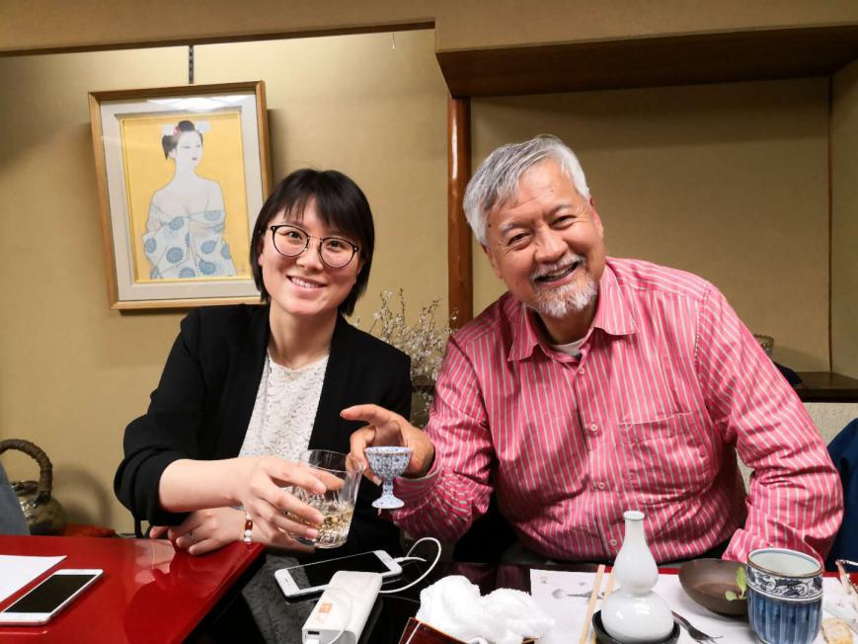

(Right: Mr. Xue Manzi, the pioneer of Chinese angel investor, left: Ms. Fan Yiyang, CEO of IMChain)

Under the flower, wine cooking. Mr. Manzi likes to talk and laugh as usual. The pioneer of the Chinese angel investment placed high hopes on the construction of the IMChian platform. He said: “The reason for investing in the IMChain intellectual chain project is to be optimistic about the ability of the platform to meet the real-time customization needs of consumers accurately and efficiently. It is a very dynamic and in-depth market, and the M2D (Manufacturing to Demand) business model is very much in line with the future development trend."

Based on this, Mr. Liu Bin, founder of IMChian, once again illustrated the concept of creating a chain of intelligence: “Interconnection, value sharing, new manufacturing model, and a new world. IMChain's groundbreaking M2D business model, Internet platform and community building fully support the increasing fragmentation and customization requirements of current consumers, to promote the connection between manufacturing capabilities and demand, to cover for the huge market gap between the current e-commerce platforms and on-demand users. that cannot provide customized manufacturing products”.

During the period, Mr. Manzi, Nan also invited his old friend the founder of UT Starcom, CEO of Yongda Intelligence Manufacture Mr. Wang Zuguang to continue the discussion. The two officials praised the progress of the IMChain intellectual chain project and believed that the intelligence manufacture chain team is a “fair and very professional” team. At the same time, they expressed that they would continue to fully support and promote the rapid development of the intelligence manufacture chain.

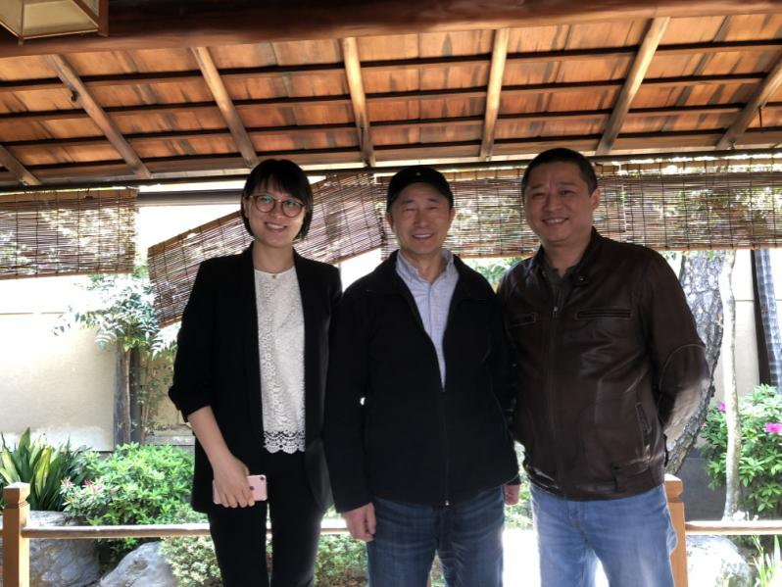

(Middle: UT Starcom founder, RongDa Intelligence Manufacture CEO, Wang Zuguang, Right: IMChain founder Mr. Liu Bin, Left: Ms. Fan Yiyang, IMChain CEO)

Based on intelligence manufacturing and blockchain technology, IMChain's intelligent chain platform supports the fragmented demand, people innovation, and discrete productivity to effectively achieve consumer and manufacturing end-to-end production. The majority of consumers propose their own personalized needs, share their own solutions, creative designs, gather the similar orders, and establish a customized cooperative intelligence agreement with intelligence manufacture factory, which is linked to the IMChain Platform, to form the all people creation, all customer production style and everybody supervision of the manufacture. In the intelligent manufacturing chain, the entire production process is transparent, joined participation, and symmetric information. It can not only accommodate the need of marketing fragmentation, and also seamlessly connects the demand to real-time production and enterprise resources.

It is believed that in the near future, the IMChain will gradually lead the smart manufacturing industry to penetrate into every corner of the public life and promote the prosperity and development of China's manufacturing 2025.

IMChain—May the creation be with you!